MicroGoal
Ideation Phase
Brainstorm & Idea Prioritization

Date | 08 march 2026
Team ID | SWTID-2026-1420
Project Name | MicroGoal
Maximum Marks

Brainstorm & Idea Prioritization Template

Step-1: Team Gathering, Collaboration and Select the Problem Statement:-
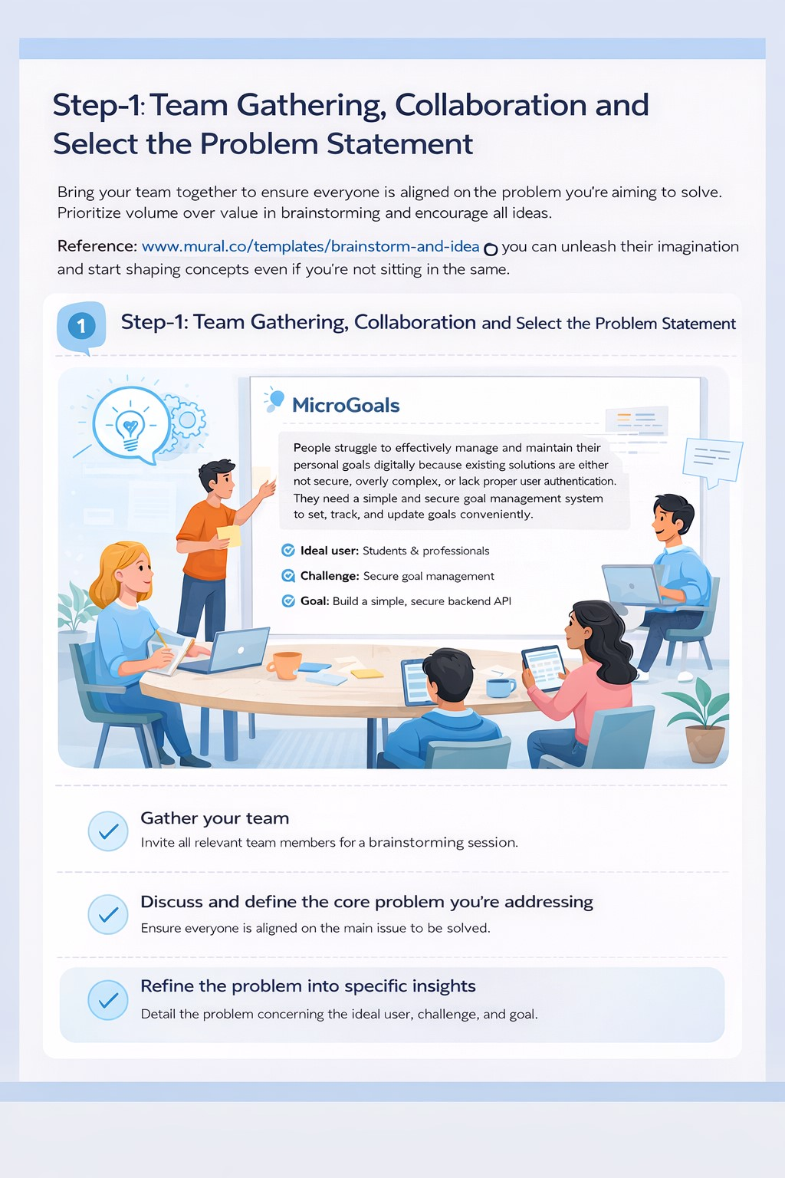

Step-2: Brainstorm, Idea Listing and Grouping:-
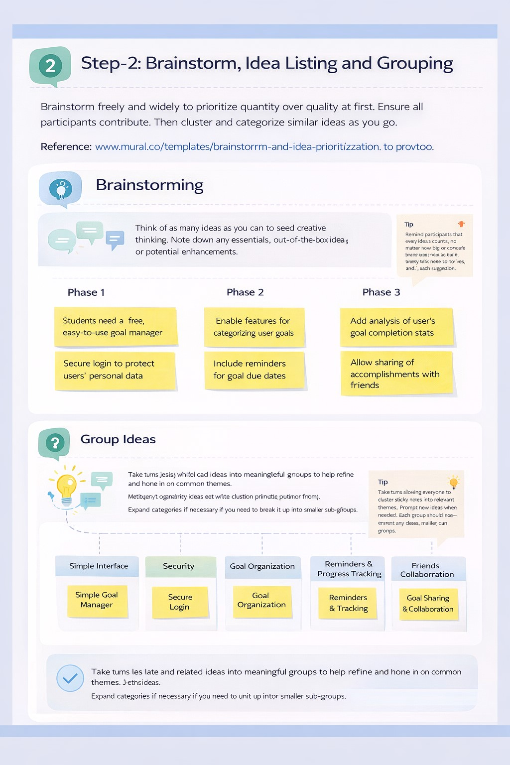

Step-3: Idea Prioritization:-
